

**Intro to Robotics: Robot Demo 3**

***“Single-motor feedback control”***

**Name 1:**

**Name 2:**

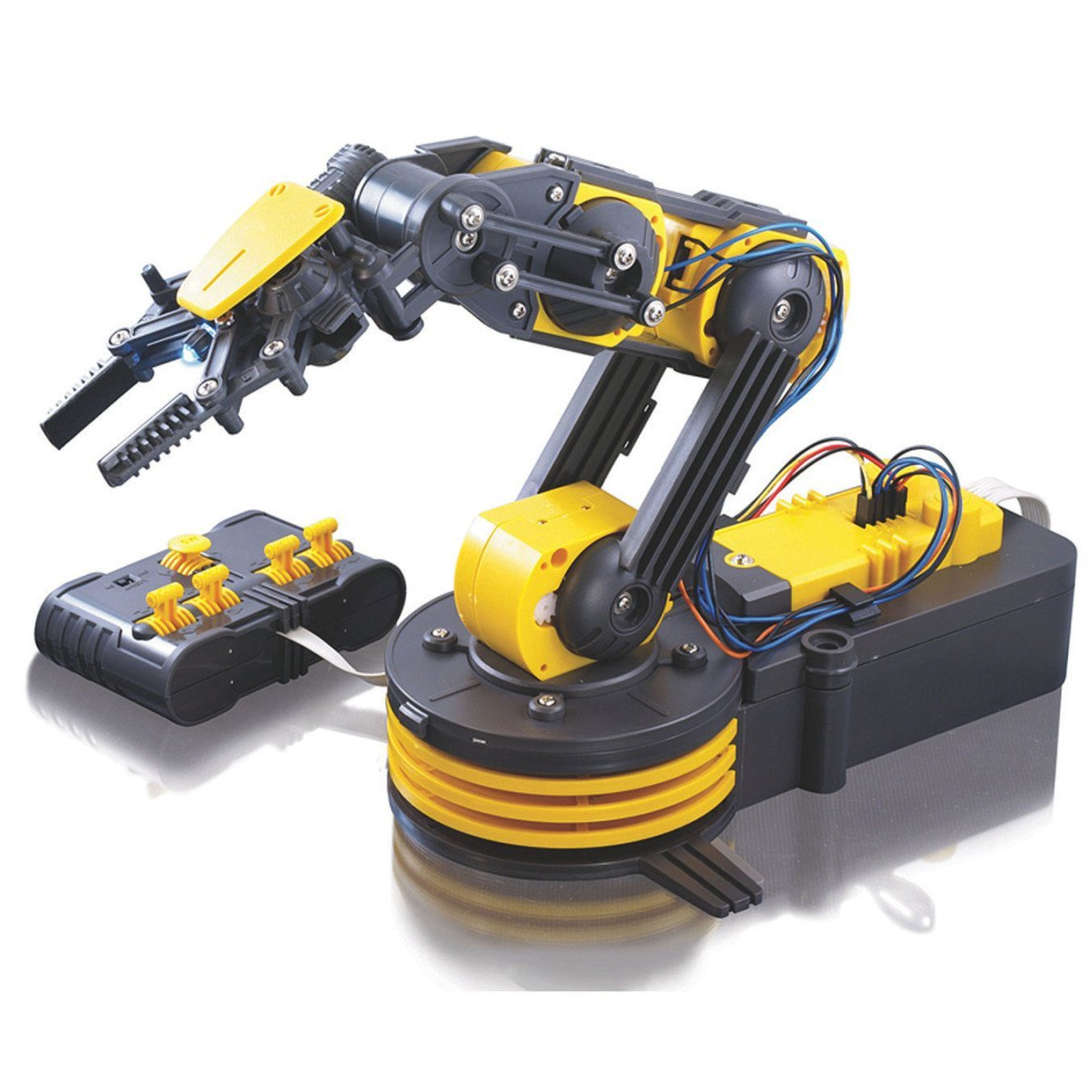

Demo 3 is worth 100 points. Give us a link to a YouTube video of your robot. The robot must have your name written on its side, and this must be visible in the video.

Add a potentiometer to at least 1 DOF of the robot.

**Test** the potentiometers **before** you start attaching them to the arm. Some may be faulty.

This will use the relay board to control at least one motor.

1. Using the Arduino, program a movement (based on the reading from the potentiometer)
2. Then have the robot move other joints to pick up an object
3. Using the Arduino, program the inverse movement (based on the reading from the potentiometer) of step 1
4. Then have the robot move other joints to place an object
5. Repeat steps 1-4 at least 5 times.

The video

* (25 pts) must show your faces & be less than 120 seconds long (you can speed up playback speed)
* (25 pts) 5 repetitions
* (25 pts) analysis of ***repeatability:*** measure the movement length & calculate the mean and standard deviation. Compare to your open-loop test
* If *Arduino* controls

|  |  |
| --- | --- |
| 1 DOF | 10 pts total |
| 2 DOF | 15 pts total |
| 3 DOF | 20 pts total |
| 4 DOF | 25 pts total |

Enjoy! Detailed build instructions follow.

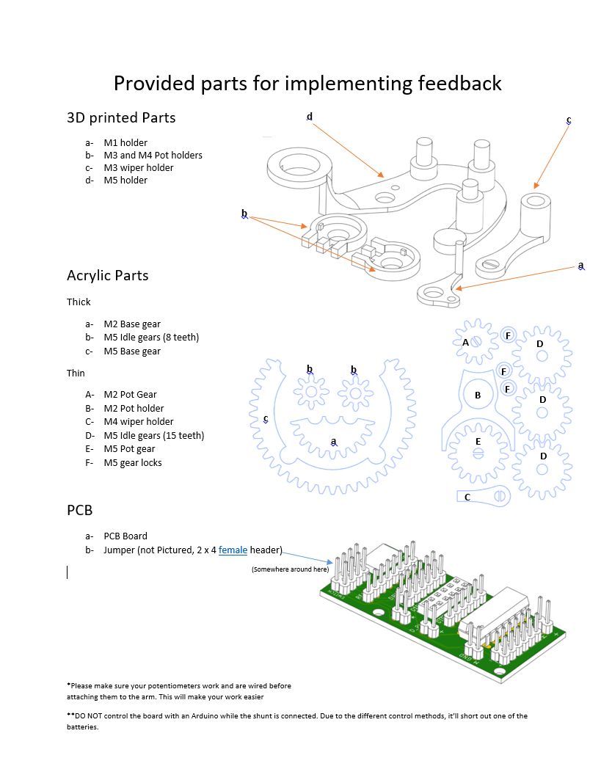

**Robot Demo 3 - Potentiometers**

Before assembling the modifications to the robot arm, it is recommended to first prepare the wiring for the potentiometers. Be sure to test to potentiometers before use (attach a multimeter to the ground and output terminals) to ensure that the resistance changes when you rotate the knob.



From: <https://randomnerdtutorials.com/electronics-basics-how-a-potentiometer-works/>

For all 5 potentiometers, the GND terminals should be connected together, as well as all +Vcc terminals. They are connected to the GND and 5V of the Arduino, respectively.

Each “output” terminal of the potentiometer should be connected to an analog input of the Arduino.

**Robot Demo 3 - Build Instructions**

Additional Supplies: Hot Glue Gun, Super Glue

1. Remove the protective film from each acrylic part.

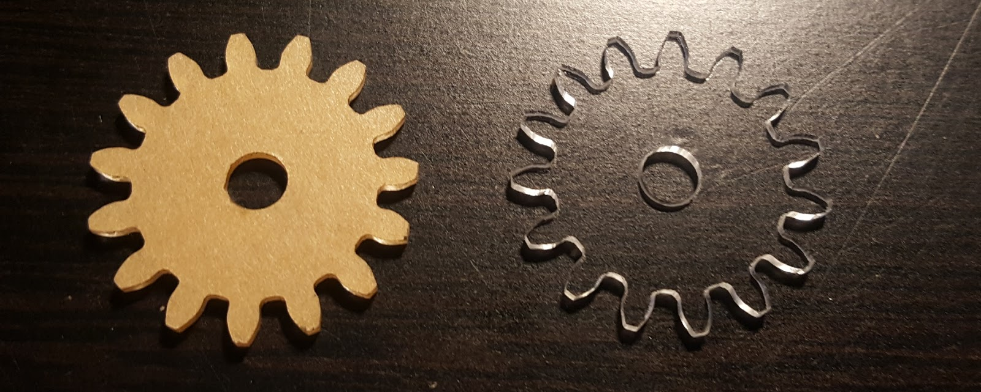

1. Remove the yellow cover at M1 (next to the gripper).  
   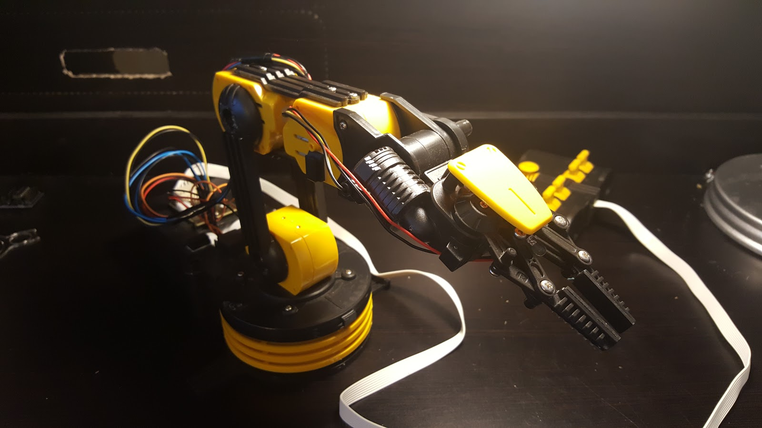
2. Insert the M5 Holder into the top right insert of the yellow cover such that the large circle of the M5 holder lines up with the screw directly below the insert.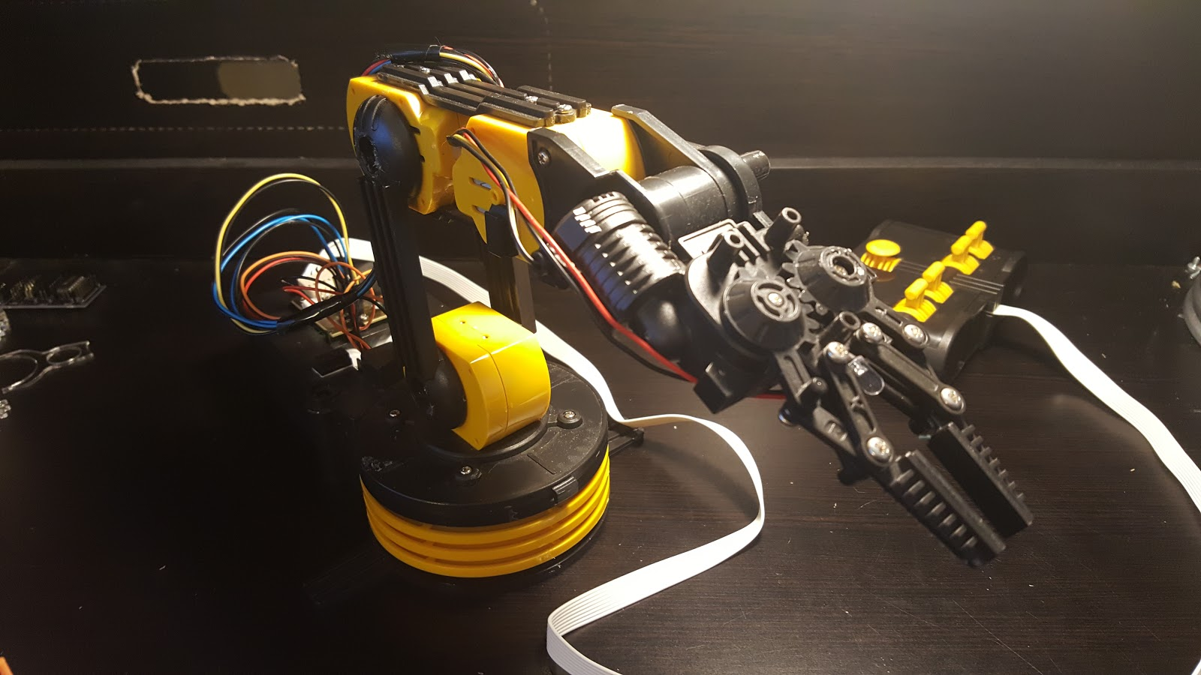

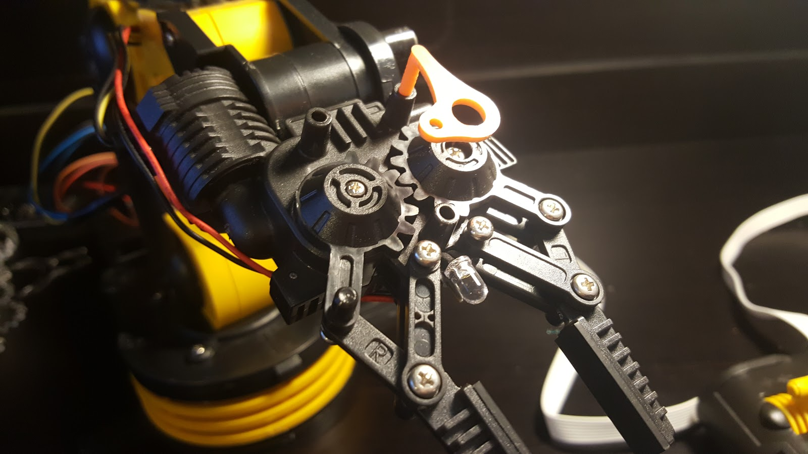

1. **Open the gripper halfway**, then make sure the potentiometer is set to **halfway between its endpoints**. Attach the potentiometer to the M5 holder.

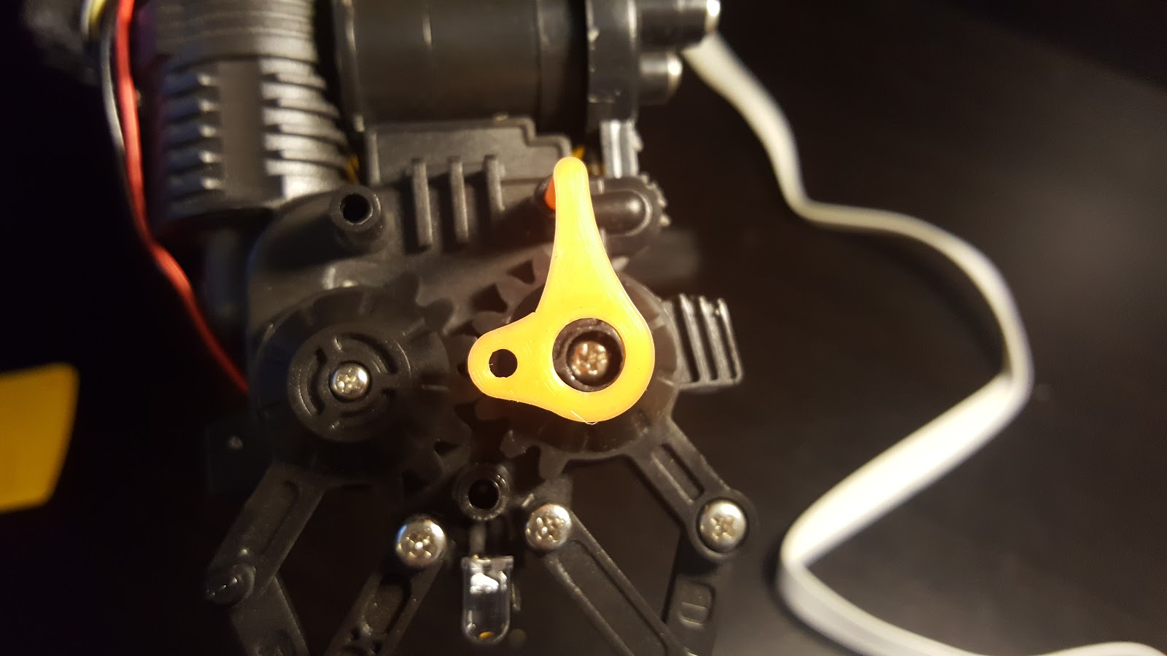

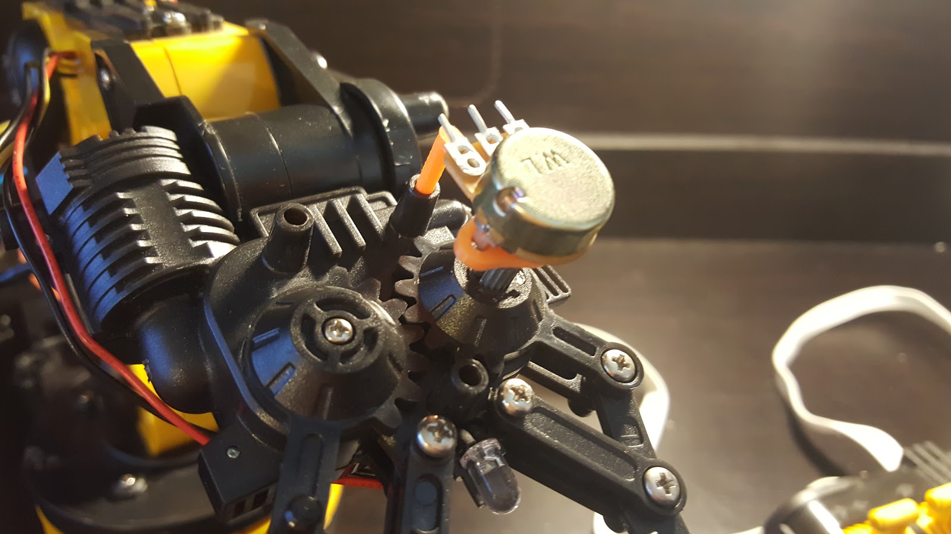

1. Set the robot arm so that it is pointing upward, then turn it to the side such that the M5 holder is **not** facing you (picture shows installed M4 holder).

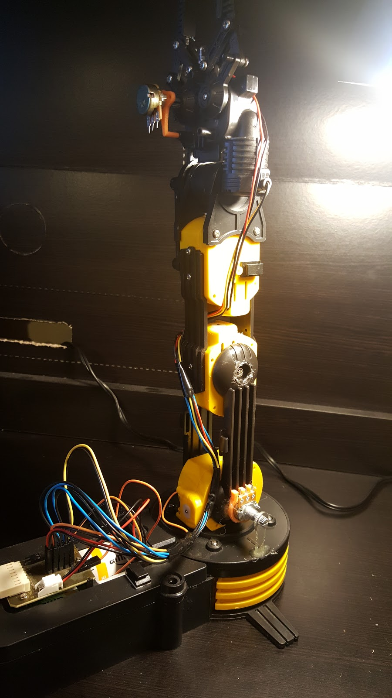

1. Place the robot on its side then install the M4 holder using hot glue. Be careful not to get glue in the hole where the screw is located.

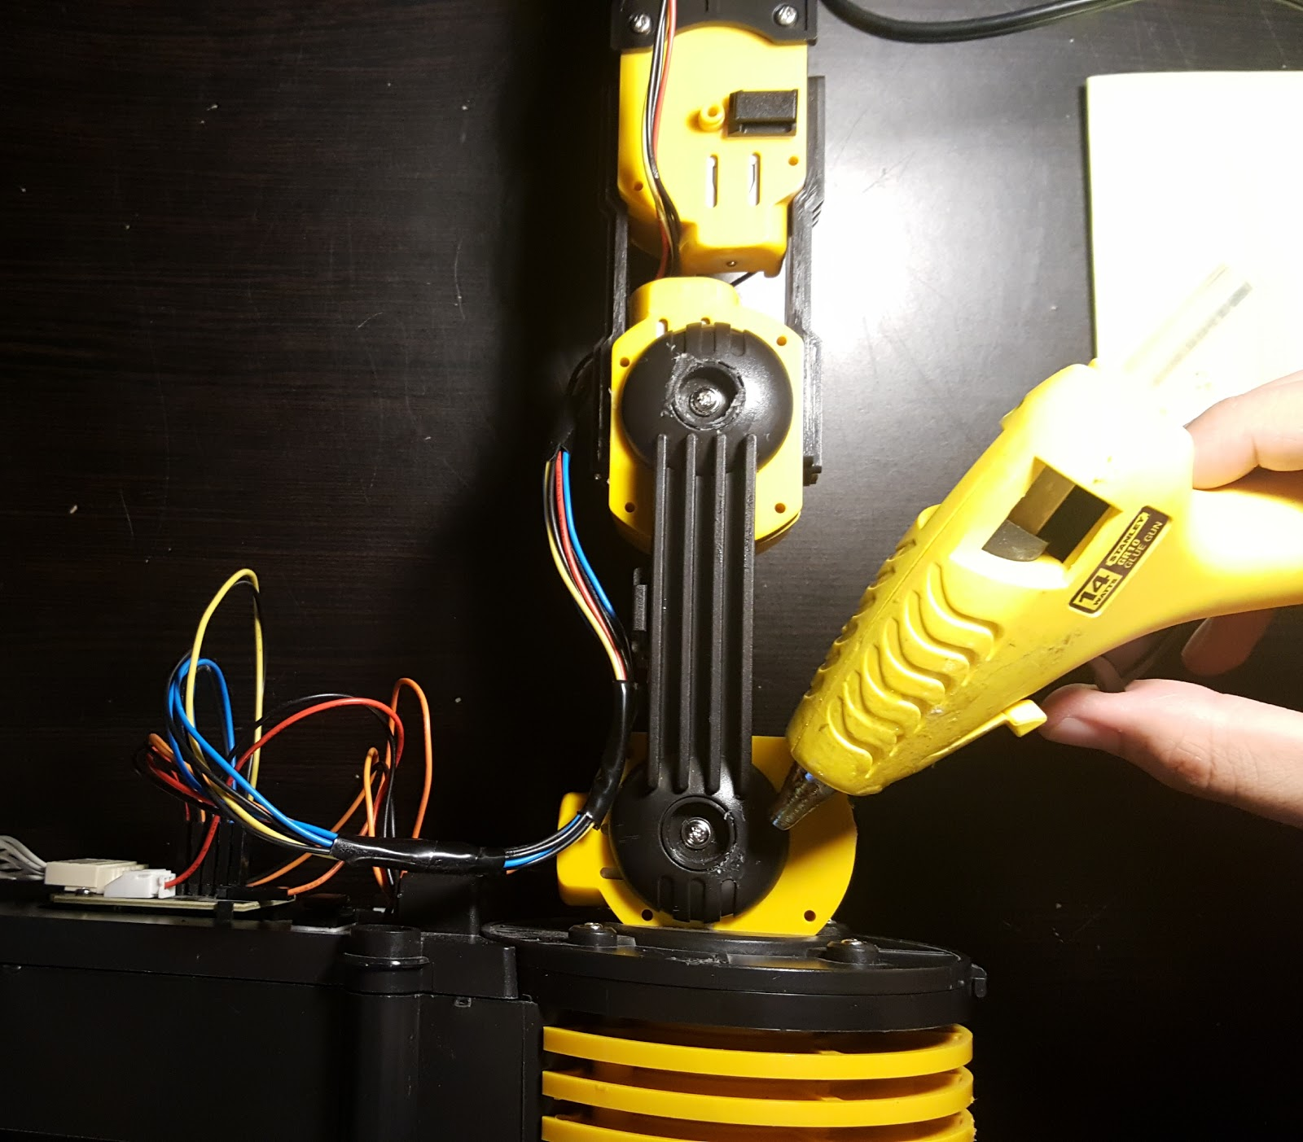  
  
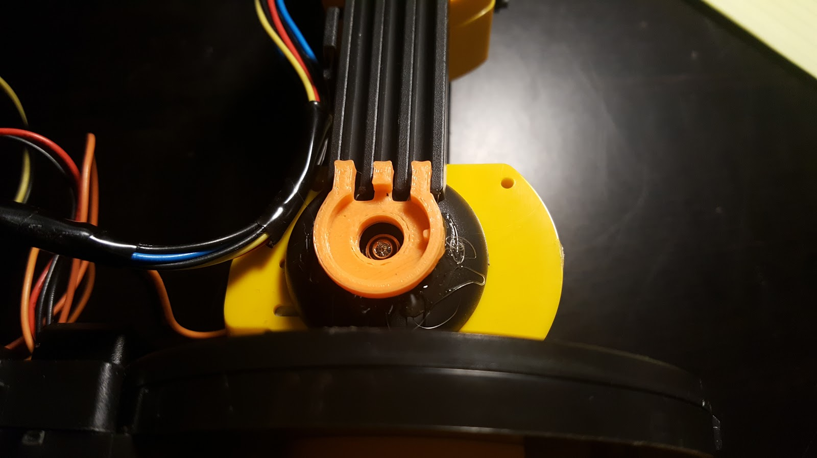

1. Make sure the potentiometer is set to halfway between its endpoints, then place in the M4 holder using hot glue. Make sure that the terminals of the potentiometer are facing upwards such that the potentiometer fits in the notch on the right side of the M4 holder (shown with red circle above).

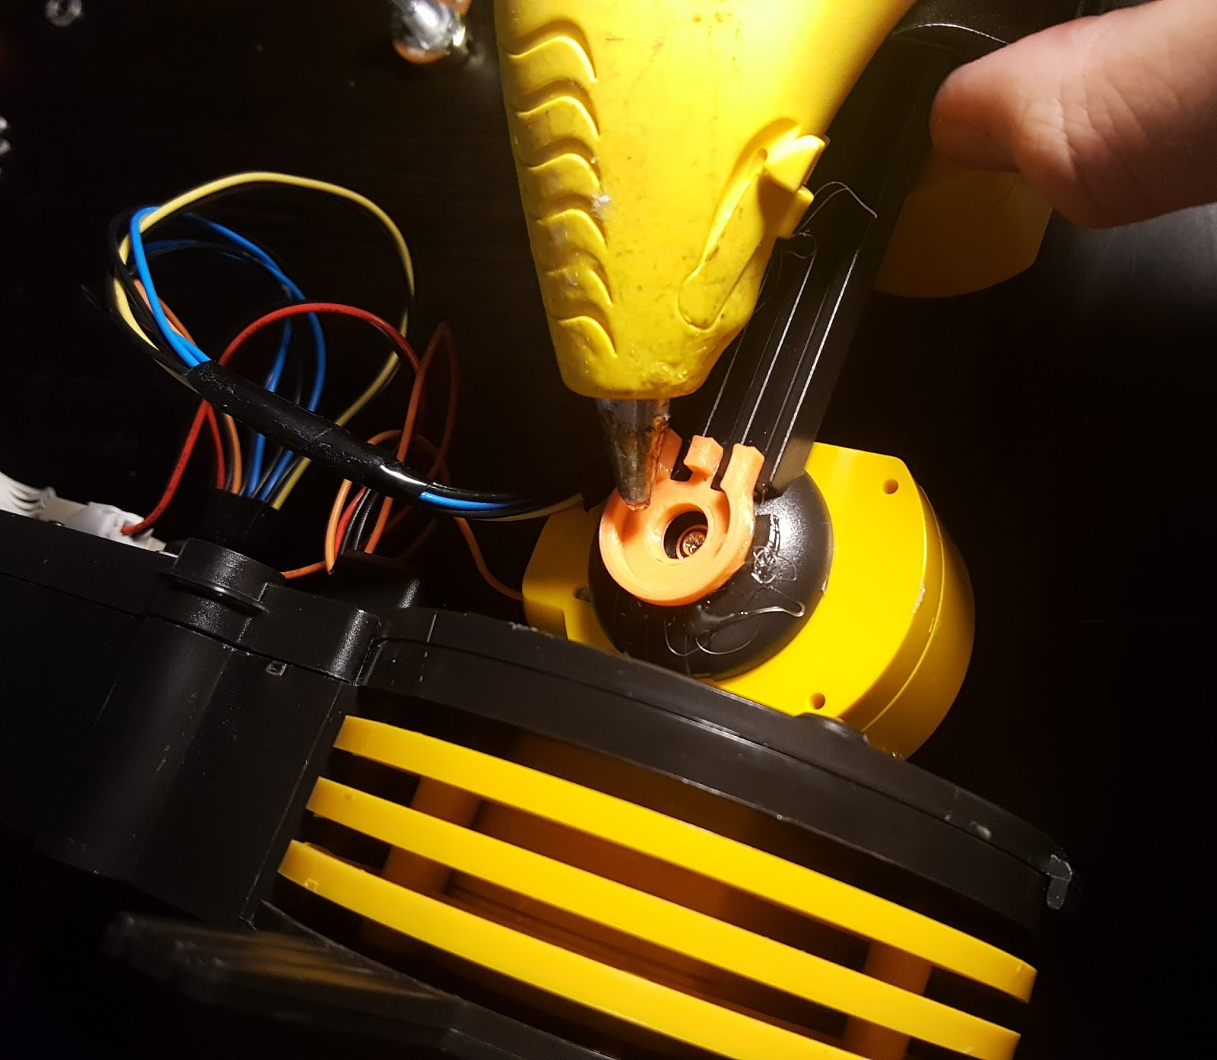  
  
  
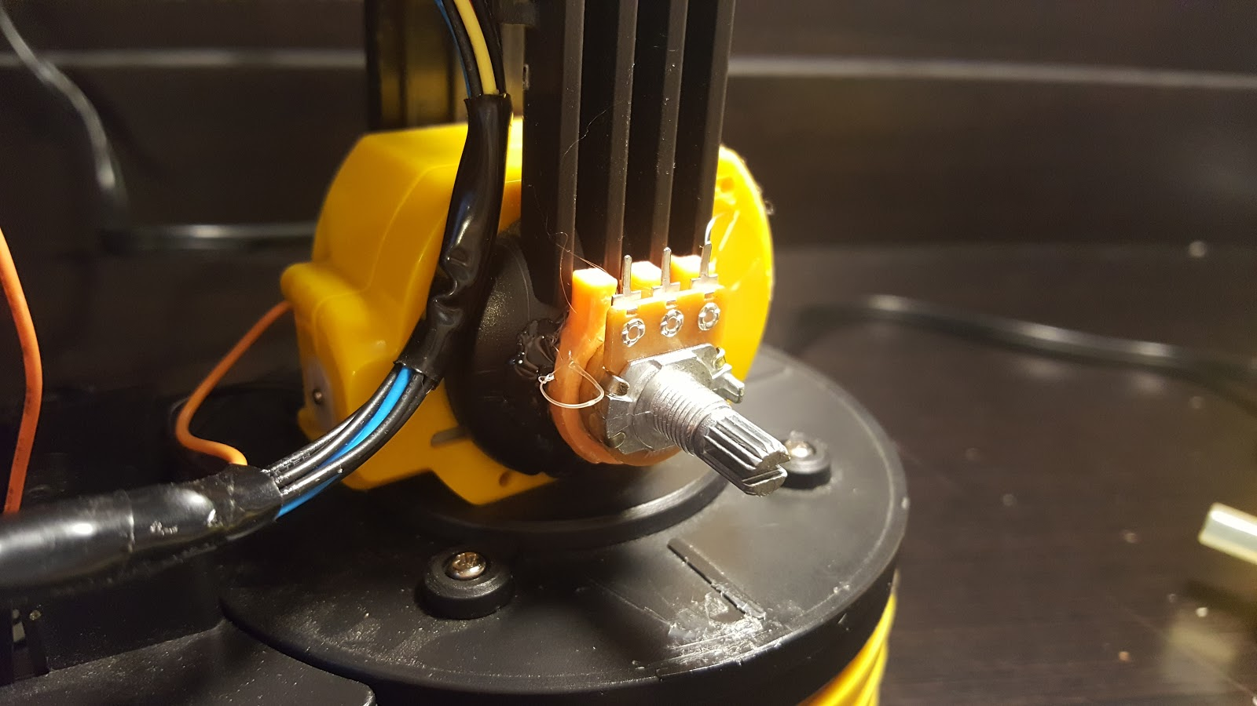

1. Insert the M4 wiper holder inside the potentiometer, then secure to the base using hot glue.

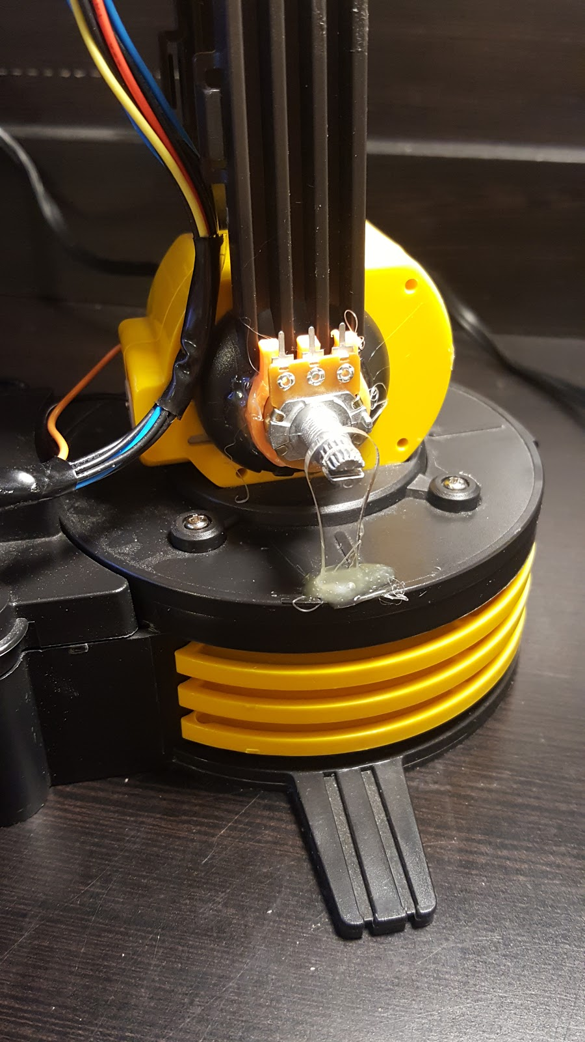

1. Turn the robot around such that the M4 holder is facing away from you.
2. Install the M2 pot holder on M3 with hot glue.

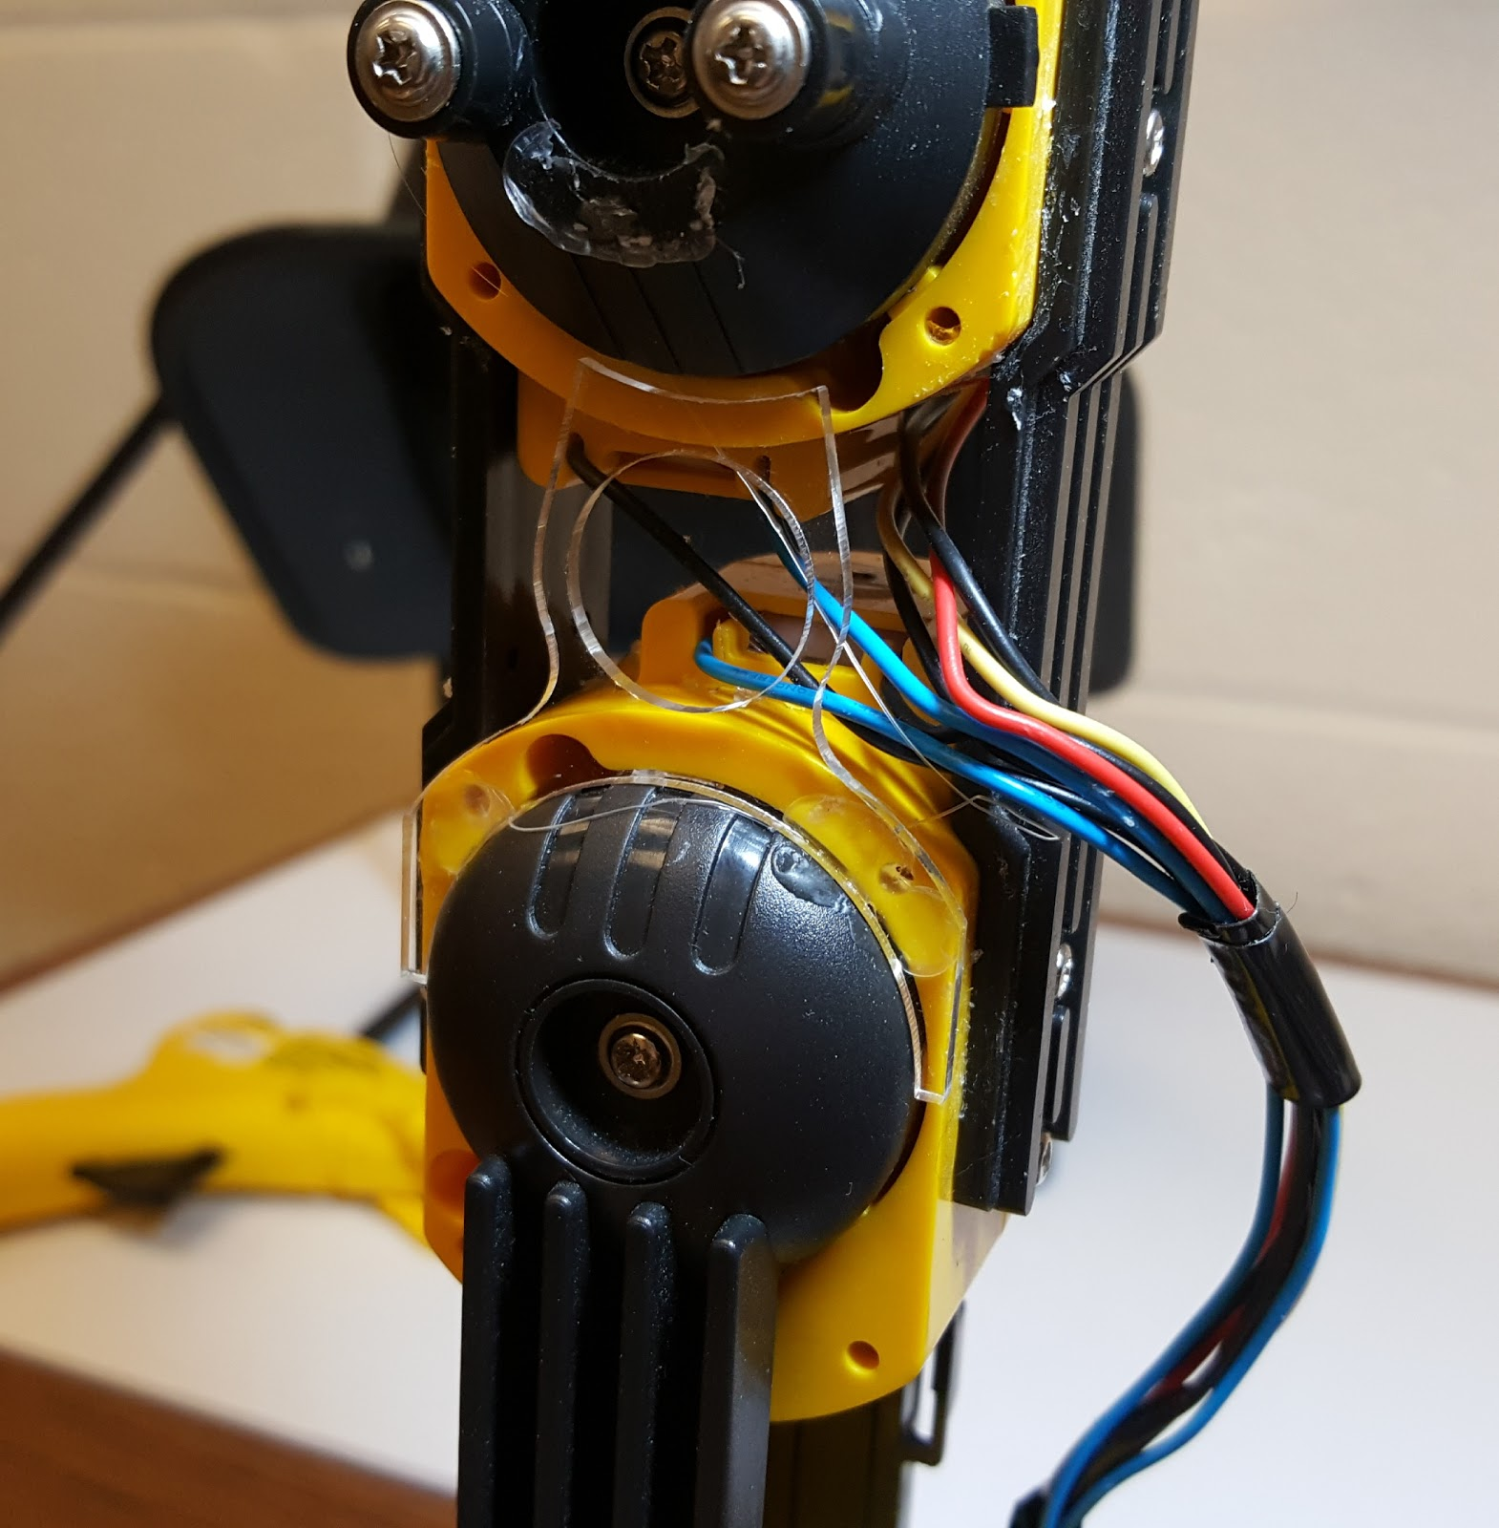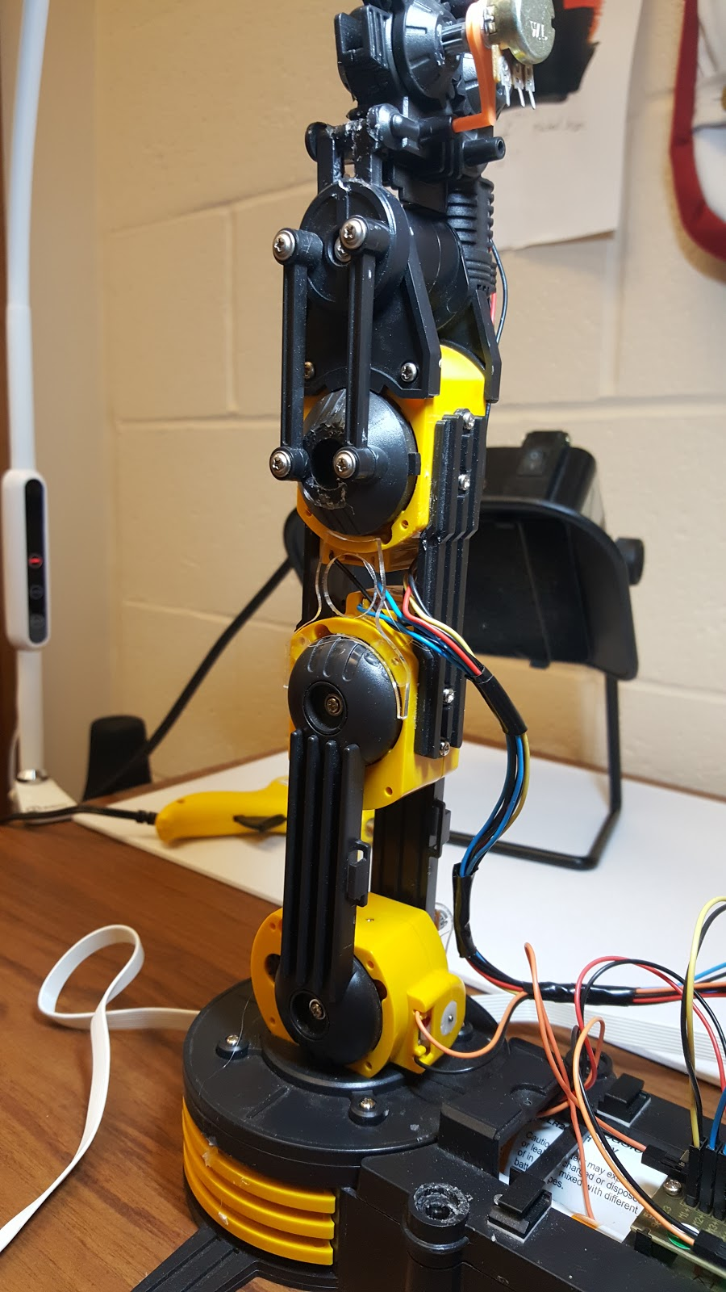

1. Install a potentiometer onto the M2 pot holder with hot glue such that the terminals of the potentiometer are facing towards the right.

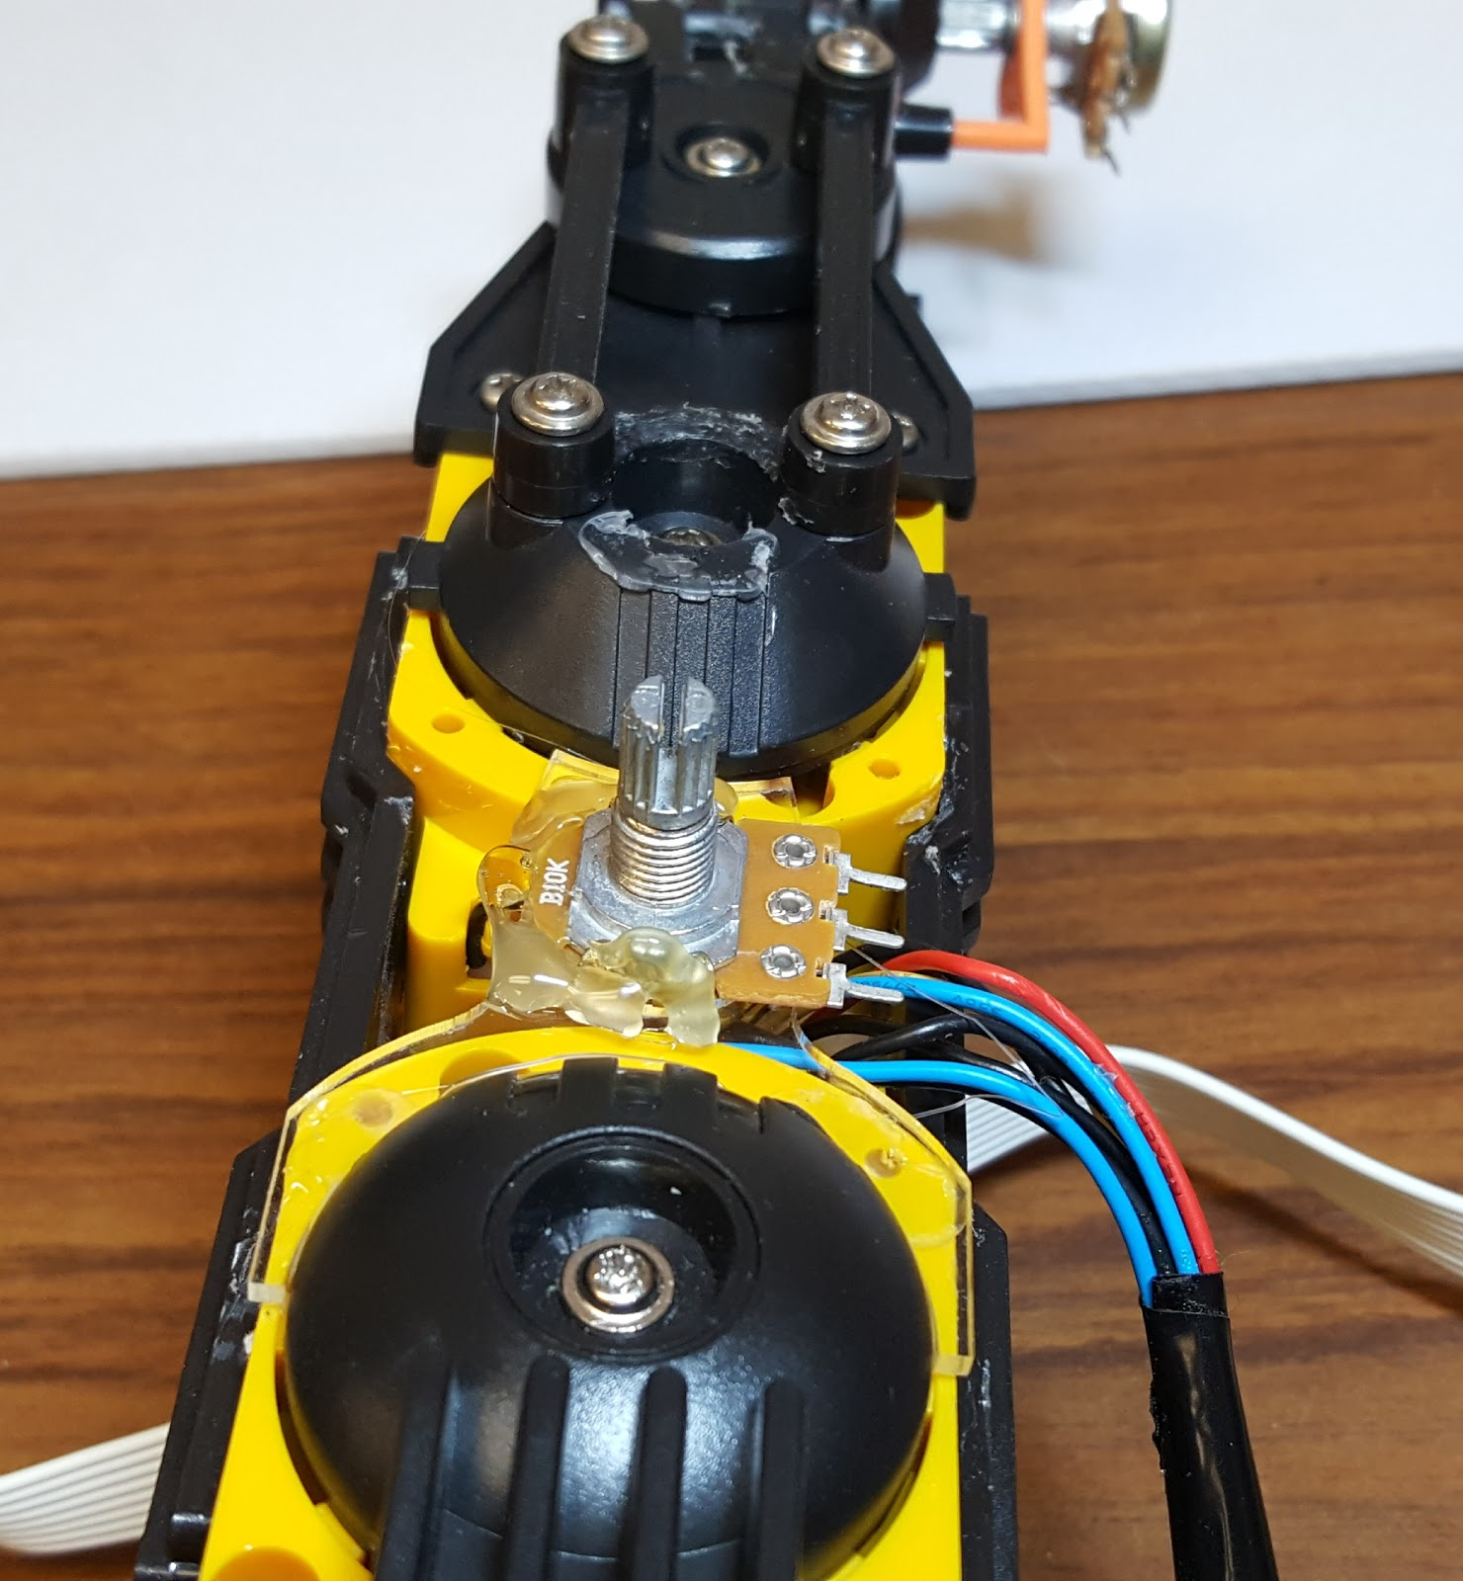

1. Install the M3 pot holder and potentiometer using hot glue.

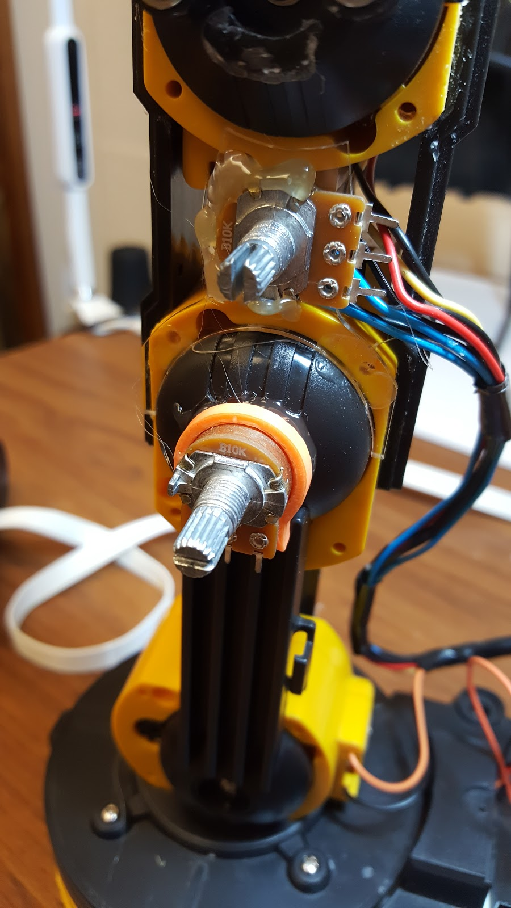

1. Make sure the potentiometer for M2 is set between its two endpoints, then insert the M2 pot gear.

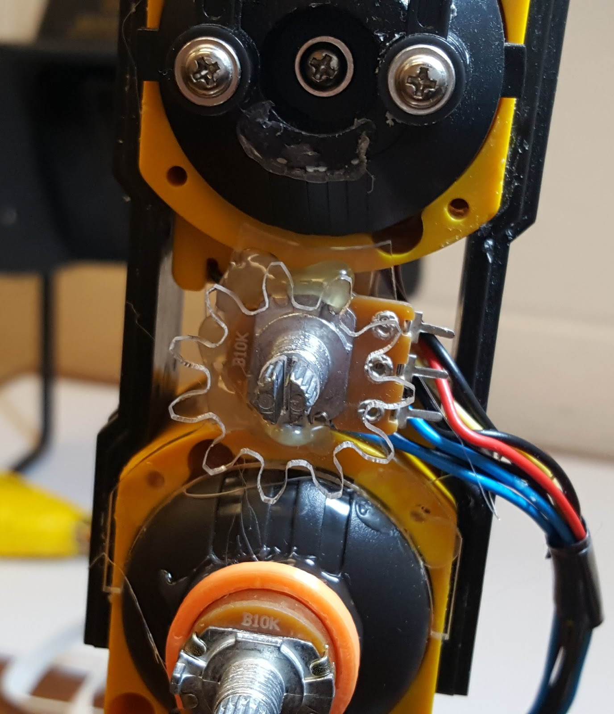

1. Using hot glue, attach the M2 base gear above the M2 pot gear (apply hot glue, lift the M2 pot gear slightly, then insert the M2 base gear). Make sure the potentiometer does not move.

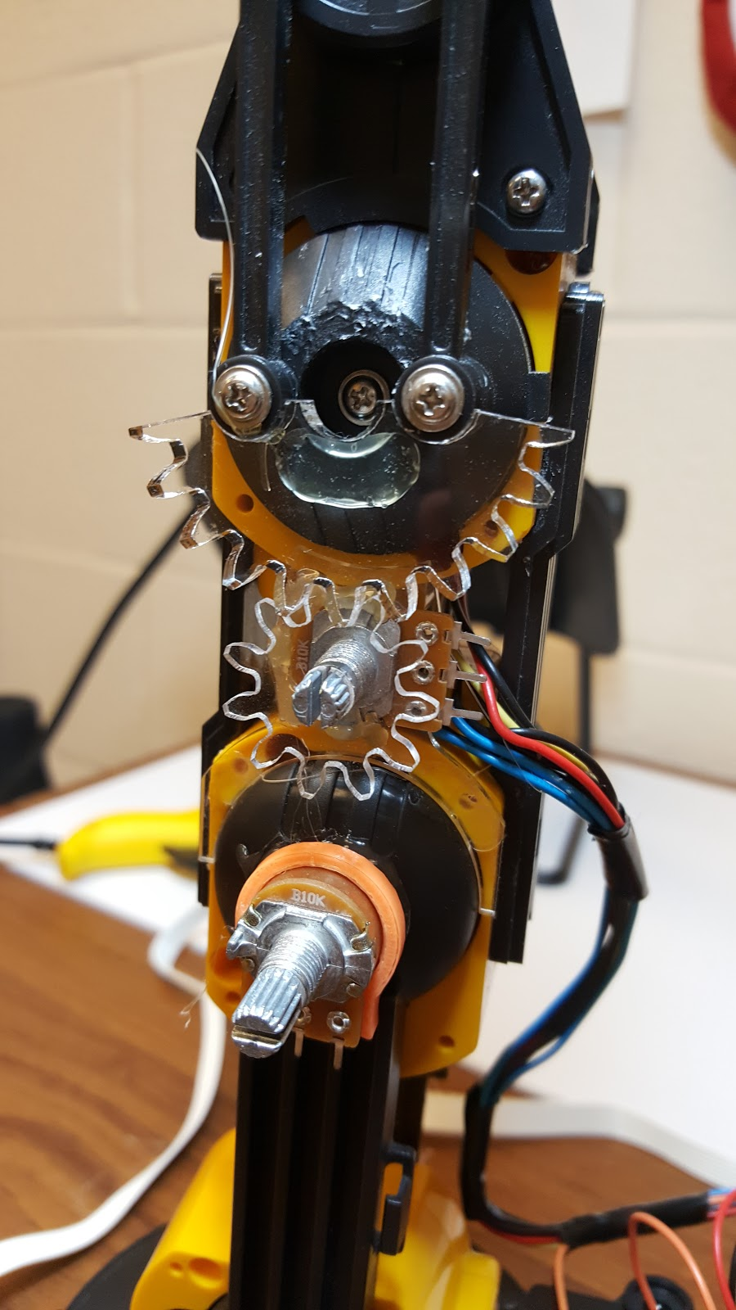

1. Make sure the potentiometer for M3 is set between its two endpoints, then attach the M3 wiper holder to the potentiometer for M3 and M4.

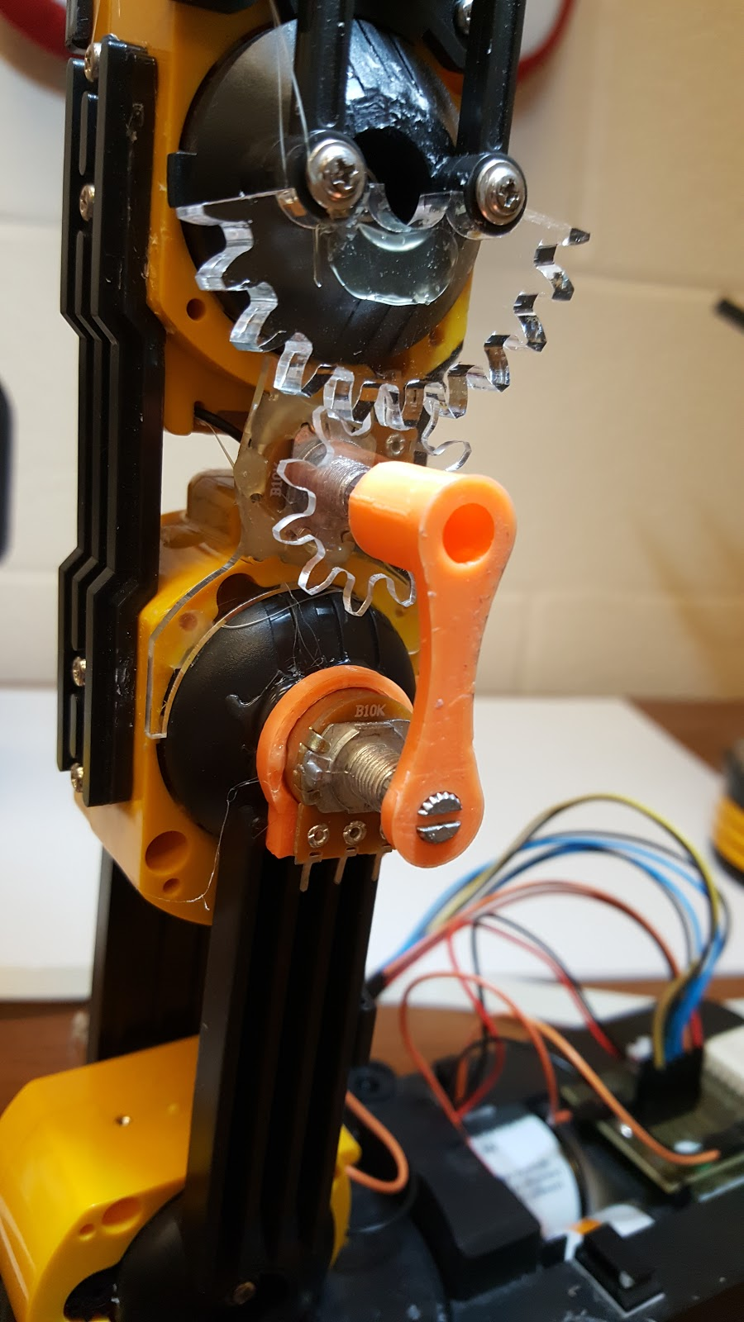

1. Use superglue to attach each M5 Idle gear (8 teeth) to two M5 Idle gears (15 teeth). Try to align both gears. One approach is to use a pencil to align the gears.

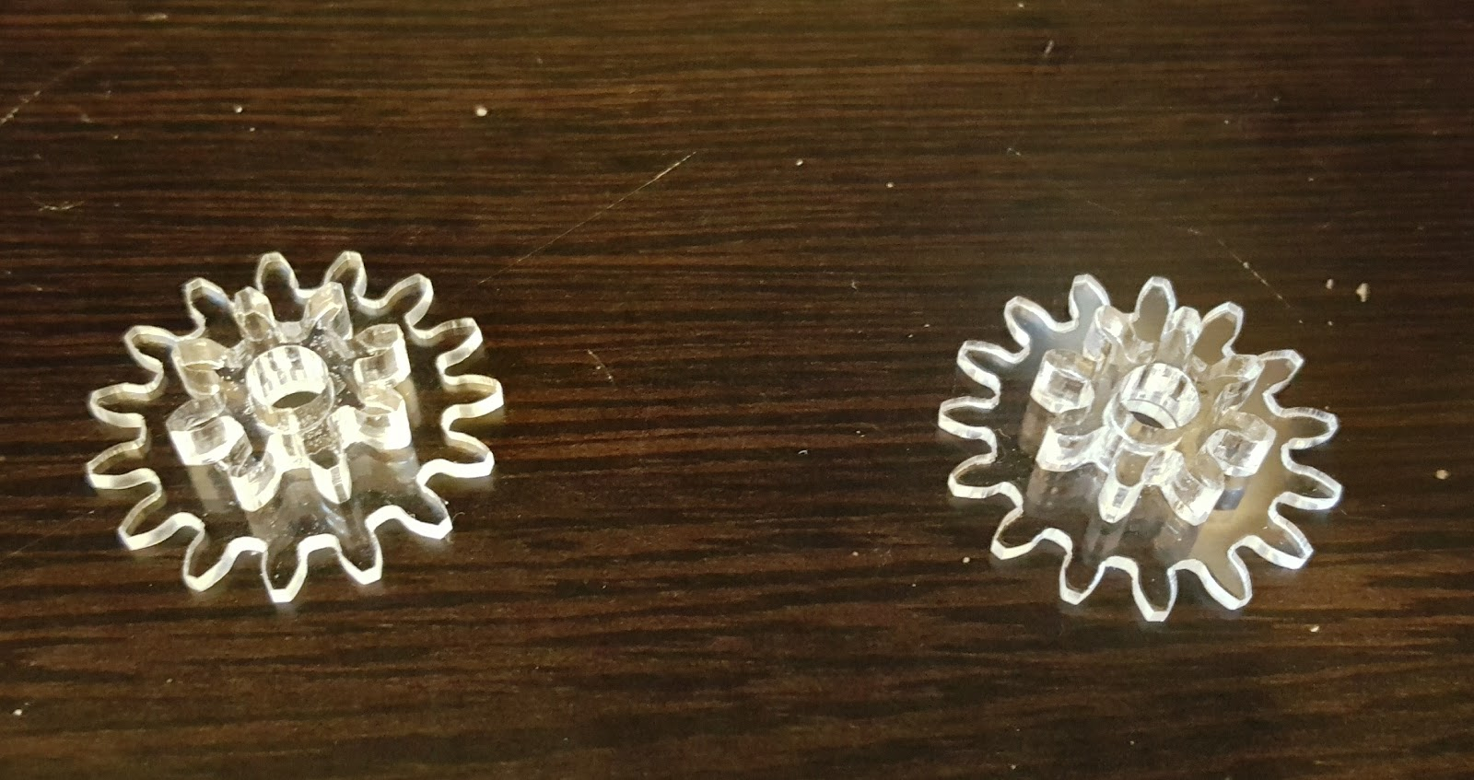 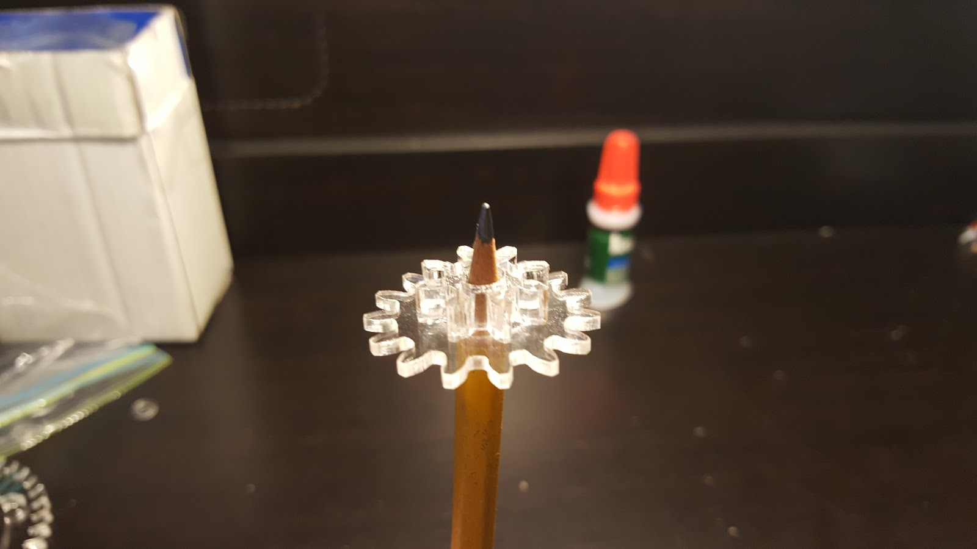

1. Attach a potentiometer to the M5 Holder, then secure using a hex nut.

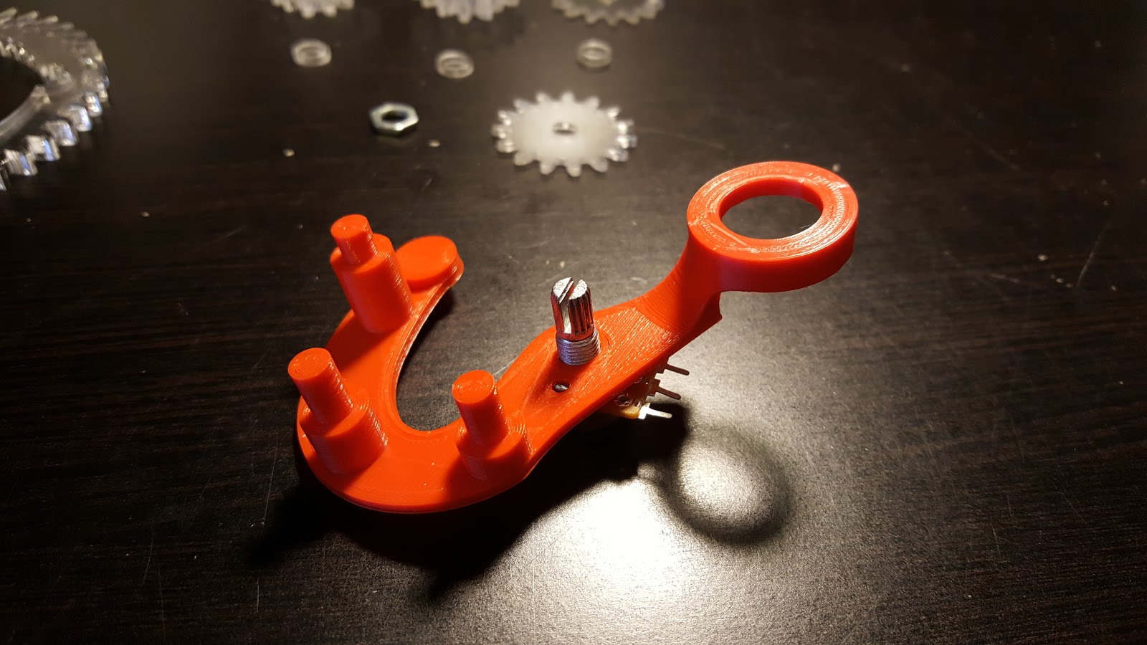  
  
  
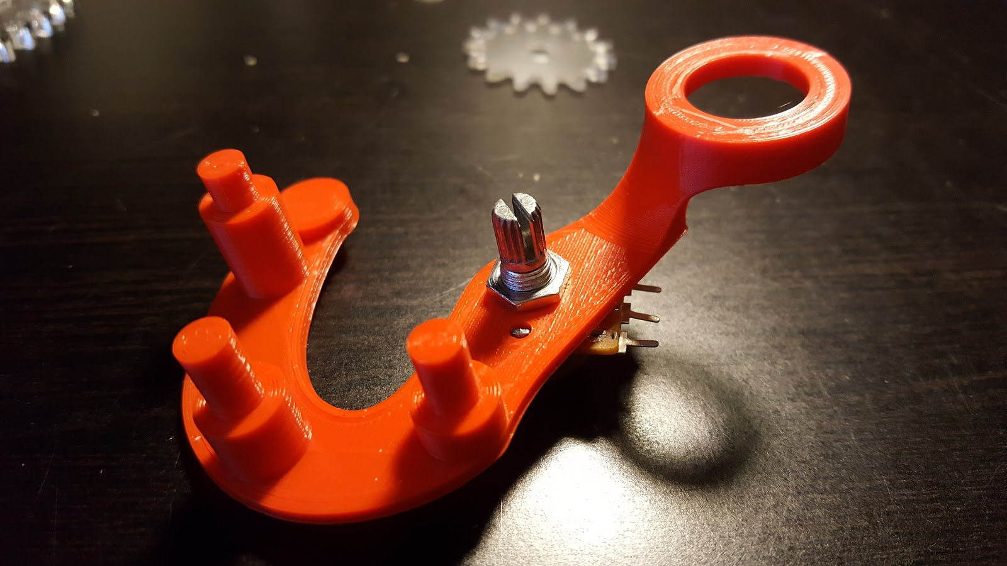

1. Make sure the potentiometer is set to halfway between its endpoints, then attach the M5 pot gear.

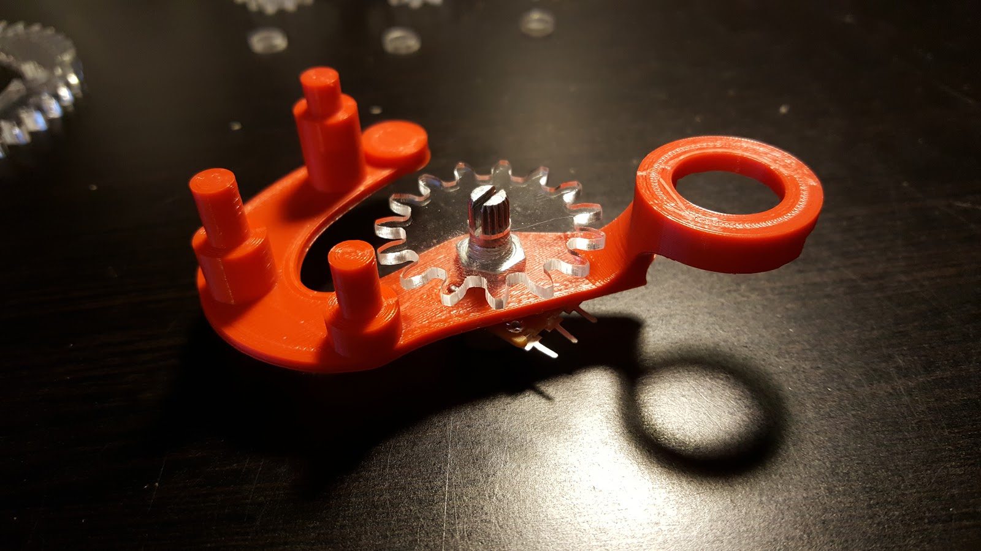

1. Insert the super glued parts to the M5 holder, with the 8-teeth M5 idle gear facing down. Then insert the final 15-teeth M5 idle gear at the M5 holder insert furthest away from the potentiometer. Be sure to keep the potentiometer between its two endpoints.

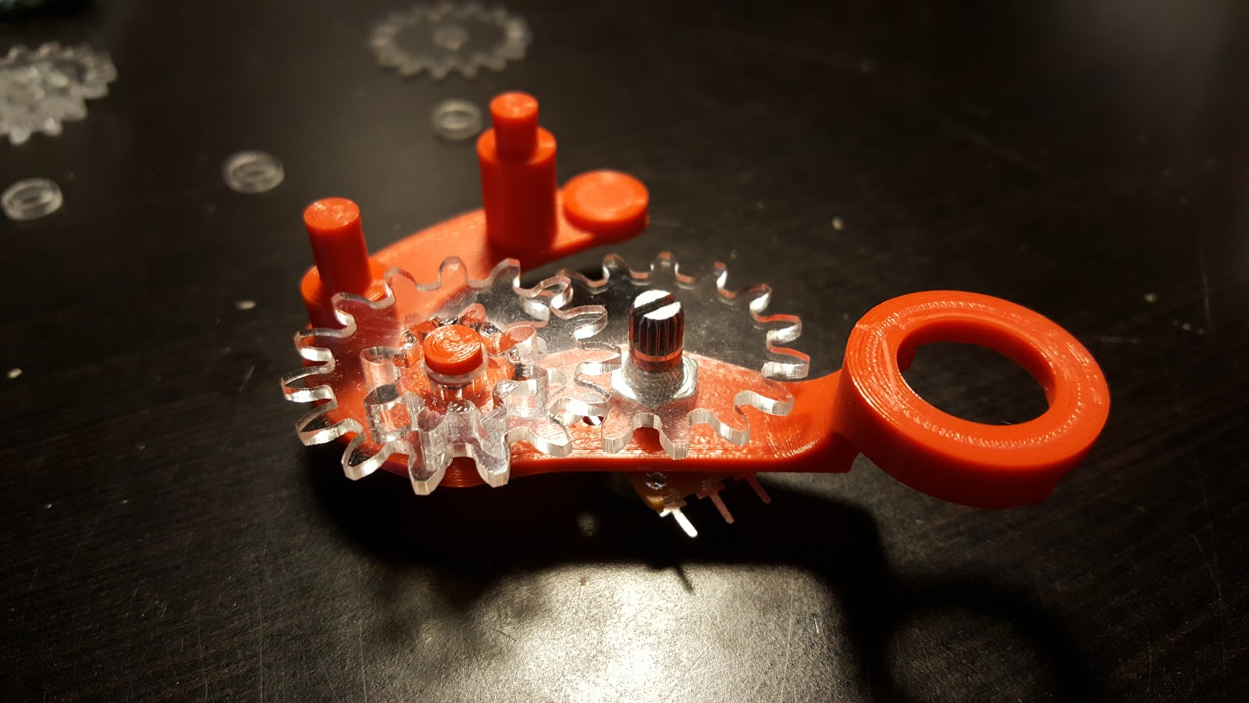  
  
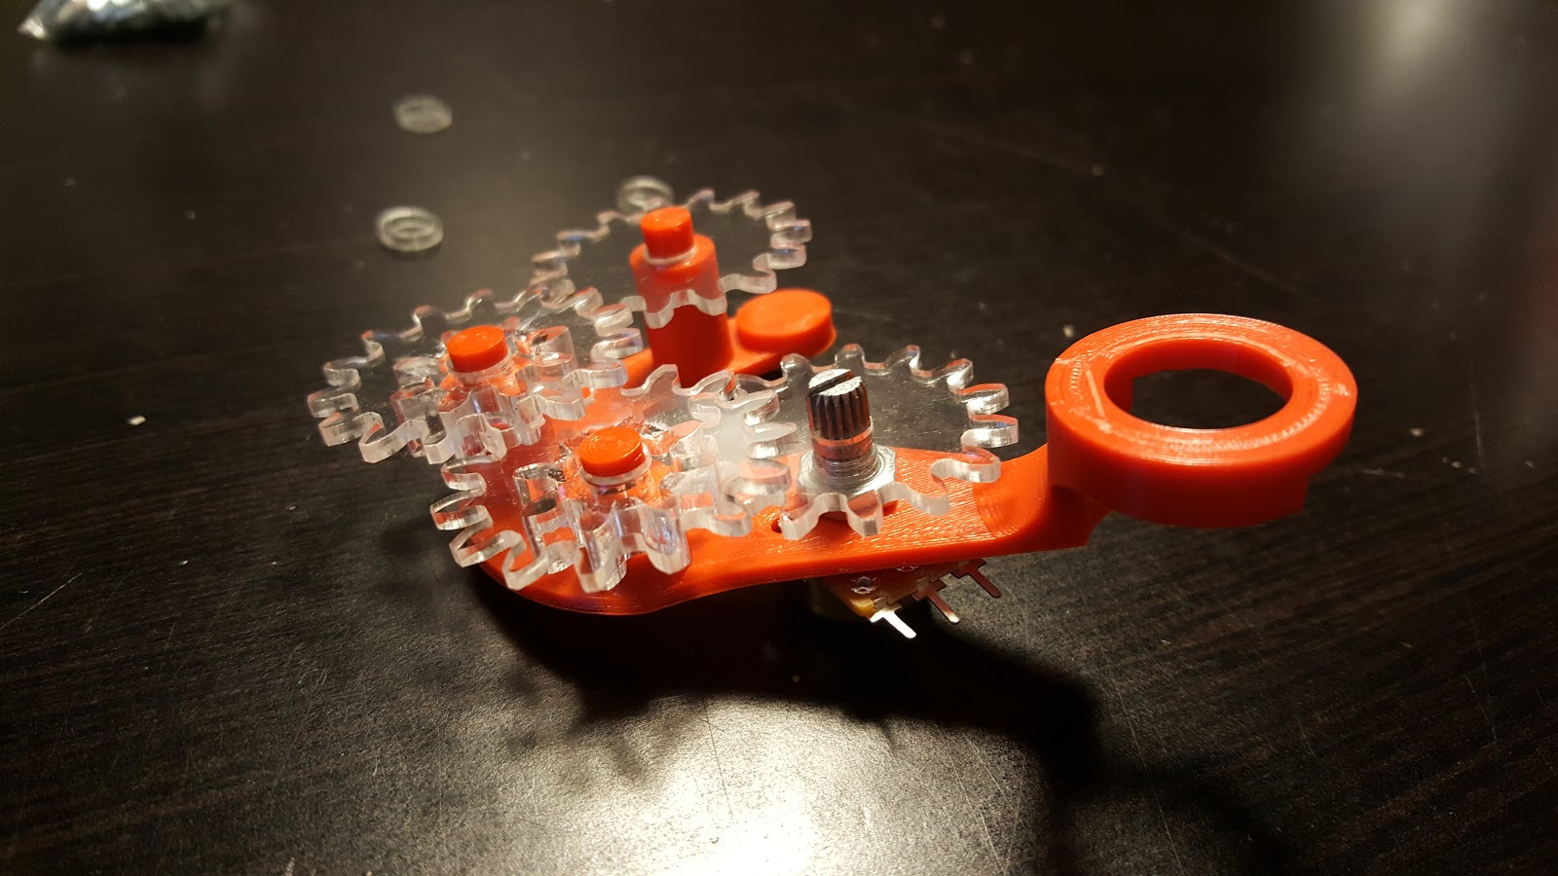  
  
  
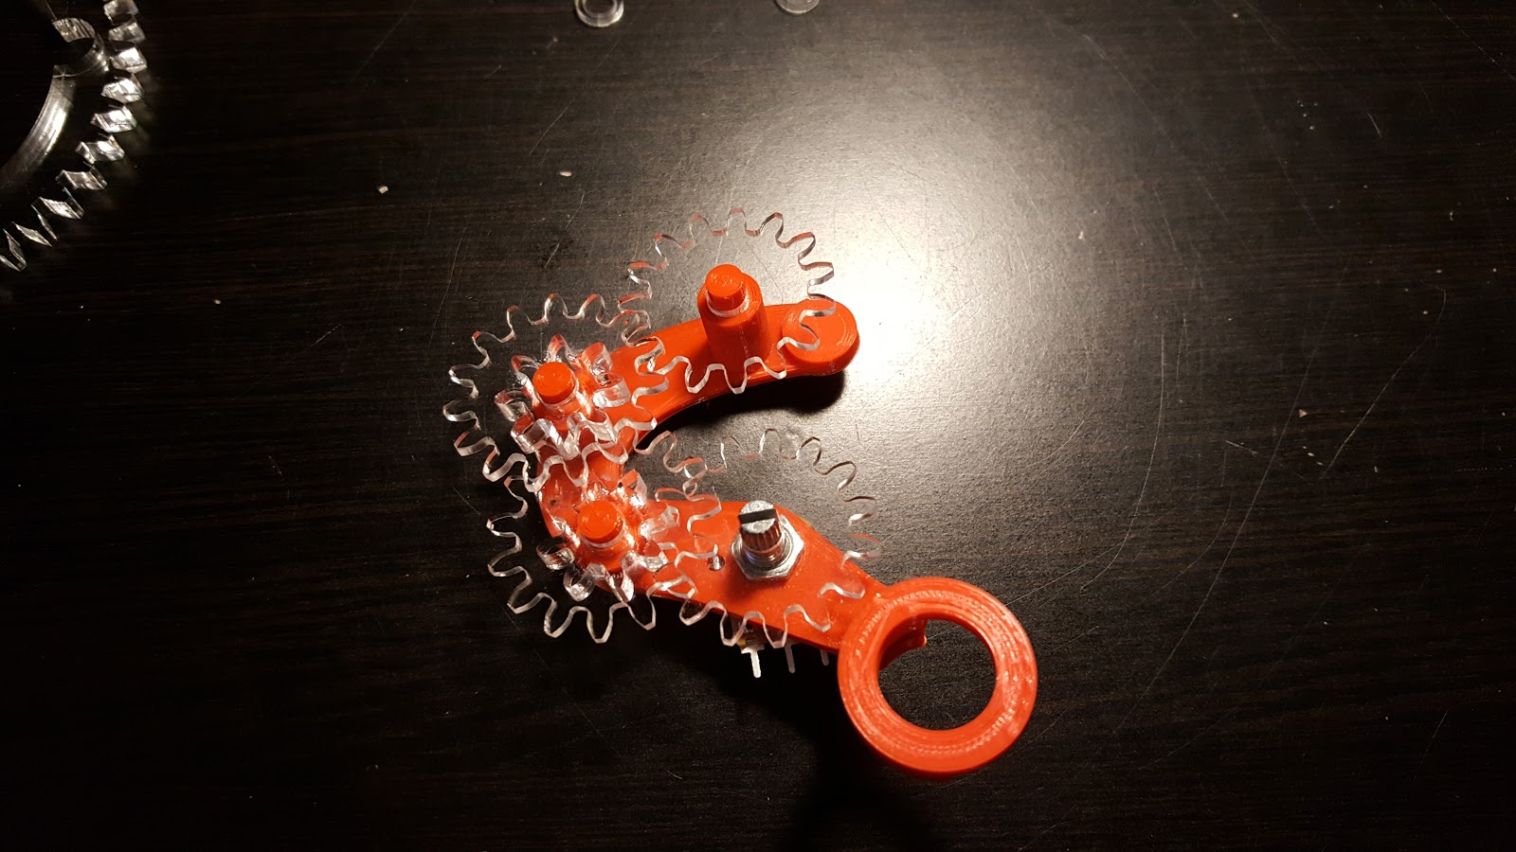

1. Insert the M5 gear locks and secure using hot glue. Apply hot glue only to the gear locks.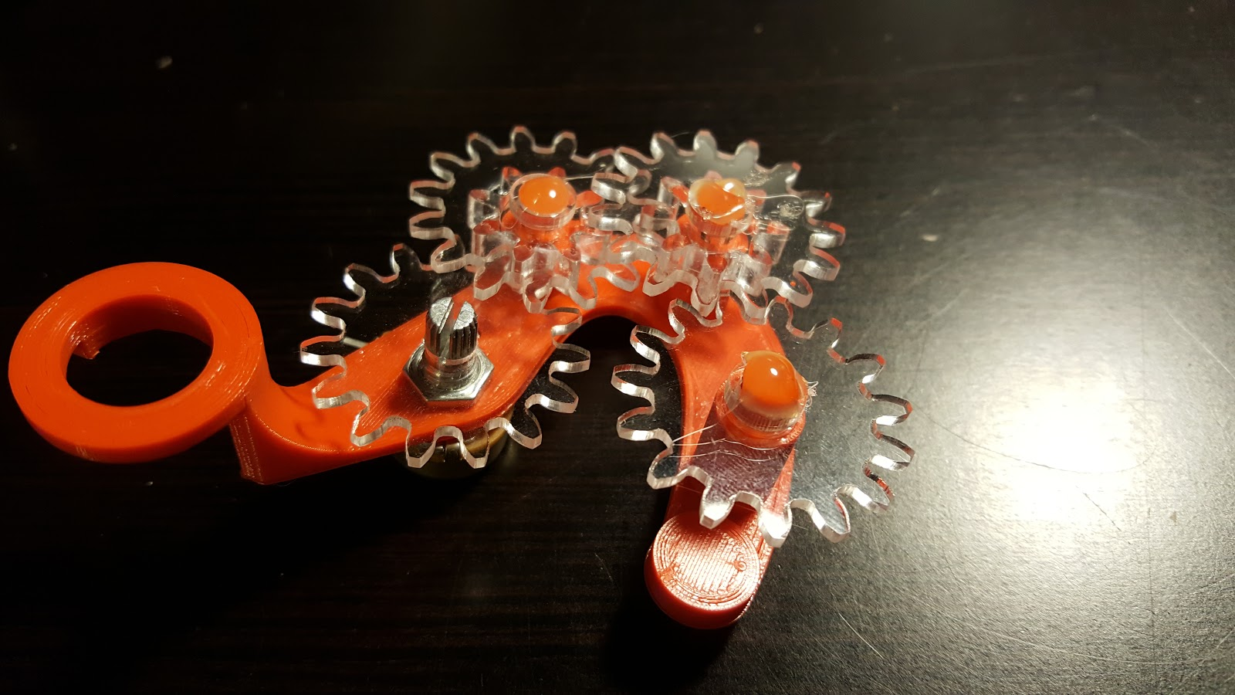
2. Using hot glue, install the M5 base gear to the base such that it is opposite the M4 holder.

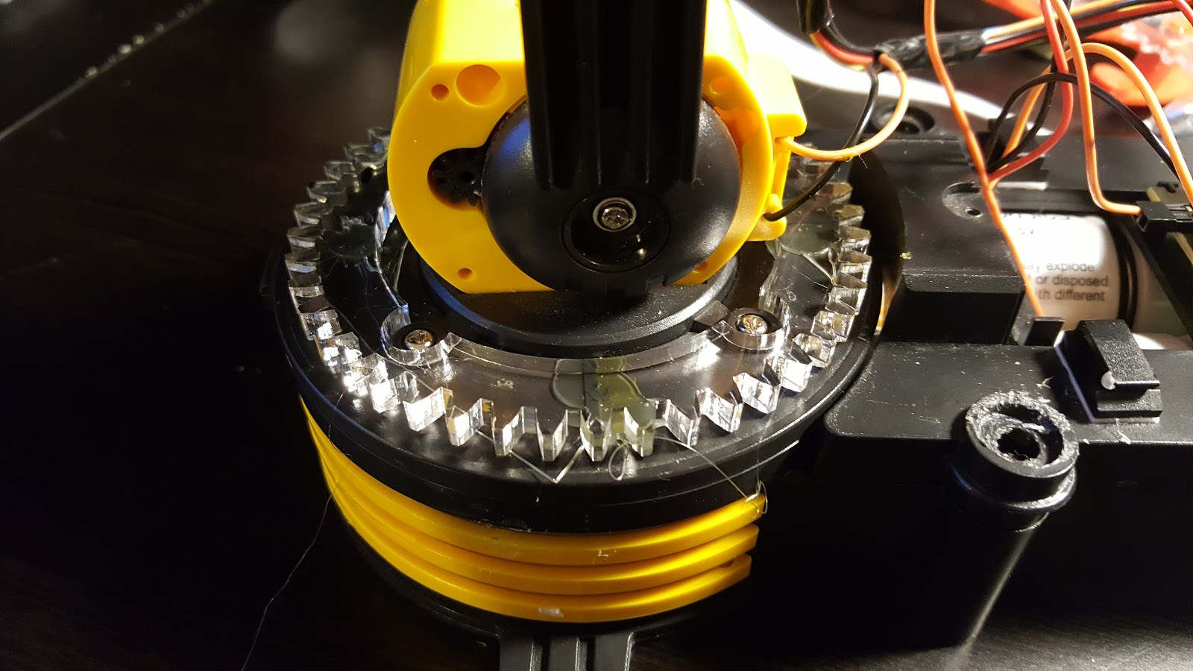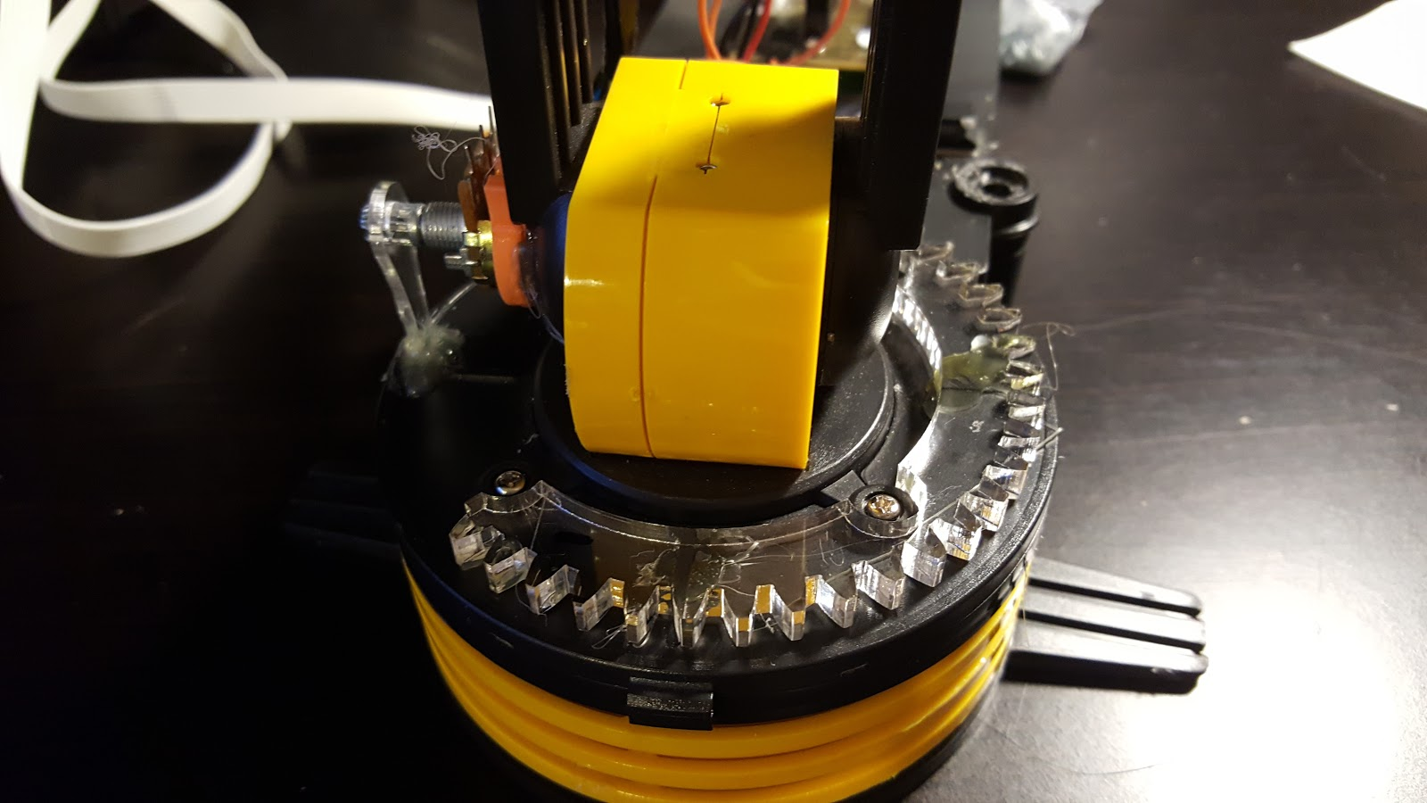

1. Install the M5 pot holder to the base as shown (magenta circles show where hot glue should be **applied first** before attaching).

